s

**Project Description:**

This project contains the networking model of computer labs in a computer block of a university. This project contains 5 labs and every lab has their own network address and is in a vlan. All these labs will be connected to a switch which is further connected to the “Main Internet Provider” (router). This router and the DNS Server will provide DHCP to the whole network. The purpose of connecting a router would be to assign a unique IP address to every PC in every lab. The router will also be connected to an administrator PC. There will also be an admin telephone connected to the switch which will be accessed directly by the telephones in every lab for any kind of complaints. In case of any fault in communication network between any PC in any lab. The wireless access point will be connected to the switch which will work as a hotspot for the laptops and smart devises within the Computer Block premises. The hotspot will contain a specific password (1234567890) through which every other device can connect to it in a networking environment.

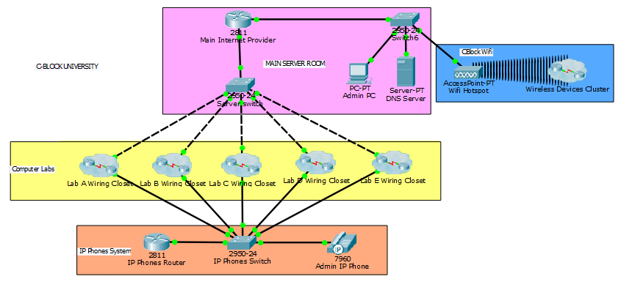

**LAB DESCRIPTION:**

In our system there are 5 labs, and, in every lab, we have 20 student PC’s, one lab attendant PC and an IP-Phone. Every device in the lab except the IP-Phone is connected to the lab switch. The lab IP-Phones will inform admin IP-Phone to address the issue with the input of administrator PC connected to the router. Similarly, the other four labs will have the same networking structure as this. Every PC in the lab will get their Ip address by DHCP. Every Lab will have their own specific network address. Every computer can communicate with each other as we are using interconnecting-VLANS. In the diagram every lab is connected in the form of a cluster. All IP-Phones are futher connected to the same switch with the 2811 router.

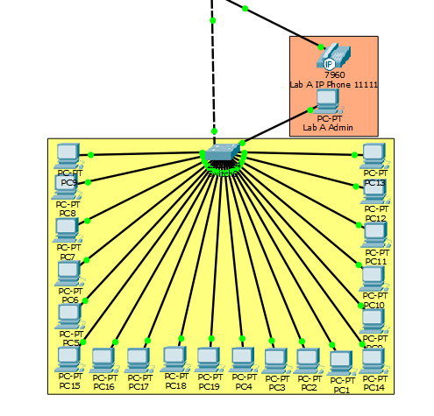

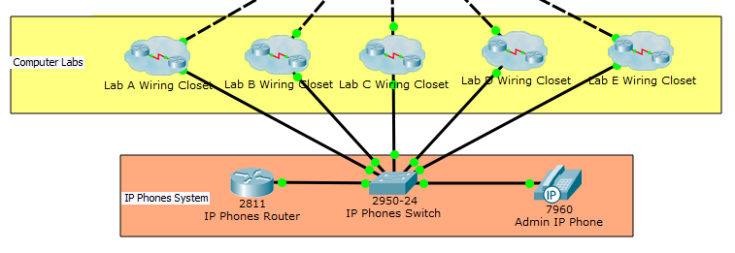

**DHCP, VLAN, SPANNING TREE, OSPF and DNS:**

The DHCP on this network was done through the router on a stick method. In this we create sub-interfaces on the FastEthernet0/0 port. The DNS is done by using a server and setting the ip-address of the dns to “cblockportal” or (192.168.10.3). This is provided to every device by DHCP. There are 5 separate vlans in this system but they can send data to each other as they are intercommunicating-vlans. The ”spanning-tree portfast” command is used when making the dhcp so that the time it take to assign a ip address to a devices is lessened. Also OSPF is implemented on the “Main internet provider” router if the Computer Block is to be connected to another Block.

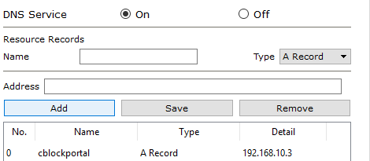

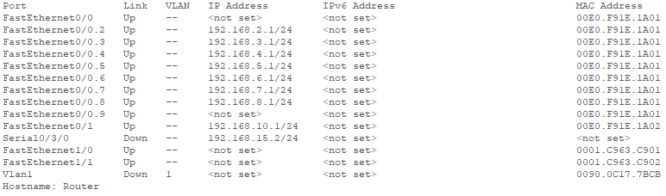

OSPF

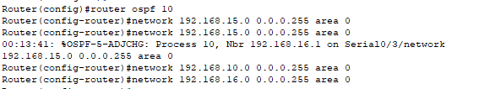

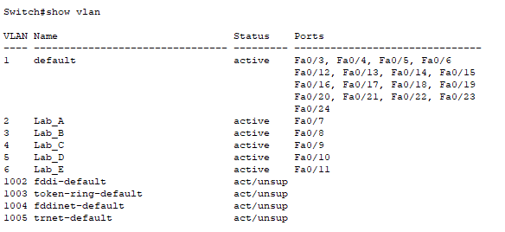

**Wireless Access Point:**

In this network there is a wireless access point which connects the various wireless devices. DHCP is implemented on the access point so every new device that is connected, is automatically given an ip address and the dns. A WPA-PSK password (1234567890) is given to the access point so that whenever a new device comes into range then it requires verification in the form of a password. The wireless access point is connected to the server switch and the range of the wireless access point covers the whole Computer Block.

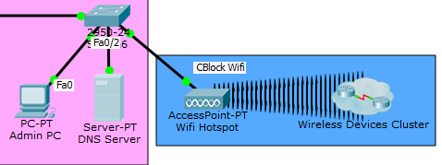

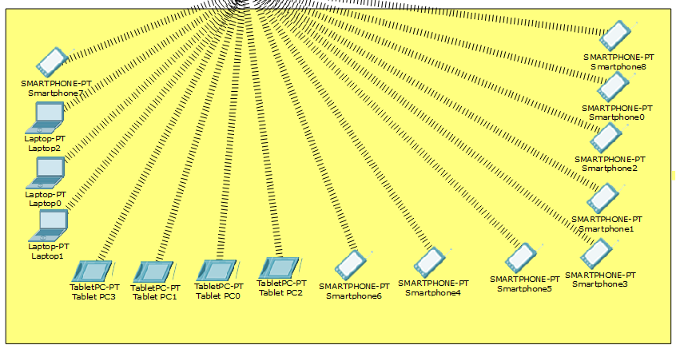

**IP-Phones:**

In this network there are six ip-phones of which five are given to the various labs and one is in the server room for the admin. Every phone of the lab and the server room is connected to a single switch with the 2811 router in the server room. Every ip-phone is given a specific phone number i.e. 12345,11111,22222,33333,44444 and 55555. Every ip phone can call every other phone on the network.

